Now as we have seen Centroid based and Hierarchical Based algorithm so we now have another type of algorithm i.e. Density Based Clustering algorithms and one of the famous algorithm is DBSCAN.

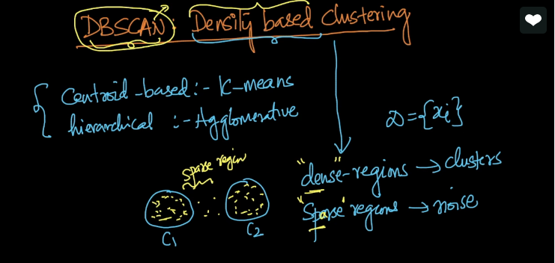

SO now we will try to form clusters based on density i.e. separate Dense regions and Sparse Regions.

So as we talk about density the one question that arises to our mind is how we calculate density mathematically?

So there are many ways as mentioned in below image.

